Jan. 17, 2021 2nd Sunday after Epiphany 11 AM
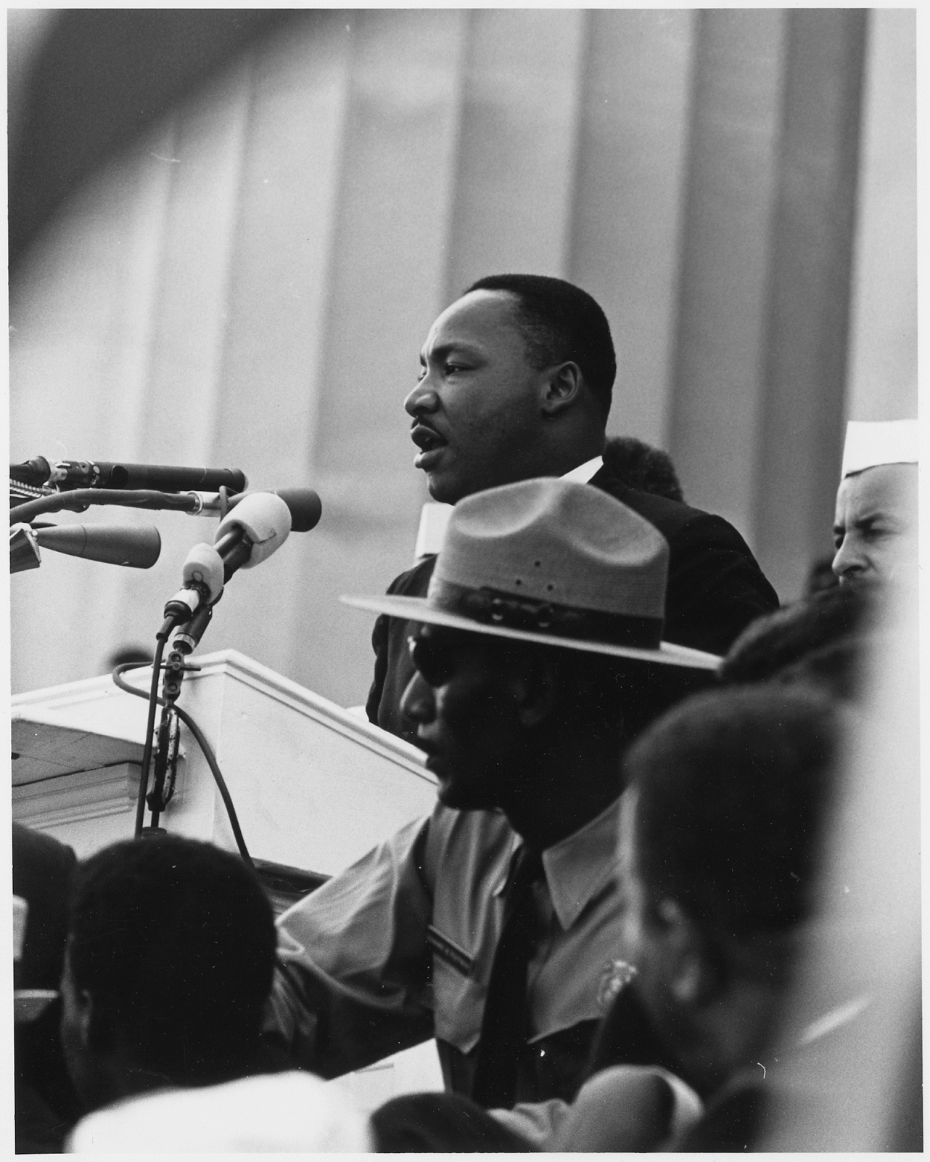
Dr. Martin Luther King, Jr. delivering his I Have a Dream Speech
at the Civil Rights March on Washington, D.C. 08/28/1963
Public Domain, Nartional Archive ARC Identifier 542069 / Local Identifier 306-SSM-4D(107)16

PRELUDE( HYMN#359) “Freedom Is Coming”
Oh freedom, oh freedom,
oh freedom, freedom is coming!
Oh yes I know, oh yes I know,
oh yes I know, freedom is coming!
Oh freedom, oh freedom,
oh freedom, freedom is coming!

WELCOME Jeff Courter

CALL TO WORSHIP Amos 5:23-24 John Biswas
Take away from me the noise of your songs; I will not listen to the melody of your harps.
But let justice roll down like waters, and righteousness like an ever-flowing stream.

*HYMN#339 “Lift Ev’ry Voice and Sing”

CALL TO CONFESSION Jeff Courter
We acknowledge that we participate in structures that are inherently racist, and yet we so often do nothing to remedy it. Show us we fail when we judge others according to the color of their flesh.

PRAYER OF CONFESSION (from the Evangelical Lutheran Church in America, 2015)
(A moment for silent confession.)
Gracious God, we thank you for making one human family of all the peoples of the earth and for creating all the wonderful diversity of cultures.
Enrich our lives by ever-widening circles of fellowship and show us your presence in those who differ most from us.
From the bondage of racism that denies the humanity of every human being and the prejudices within us that deny the dignity of those who are oppressed, Lord set us free: Lord, have mercy.
From racism that blinds oppressors to the destruction caused by the spirit and practice of racial injustice, Christ set us free: Christ, have mercy.
From the racism that will not recognize the work of your Spirit in other cultures: Lord set us free: Lord, have mercy.
Forgive those of us who have been silent and apathetic in the face of racial intolerance and bigotry, both overt and subtle, public and private.
And take away the arrogance and hatred that infect our hearts.
Break down the walls that separate us.
And help us to find that unity that is the fruit of righteousness and will enable us to become your beloved community.
Empower us to speak boldly for justice and truth and help us to deal with one another without hatred or bitterness, working together with mutual forbearance and respect.
And work through our struggles and confusion to accomplish your purposes.
O God of unconditional love, you who show no partiality in respect to people or nations, we have heard your good news of great joy for all the people. We hear that good news, and in hearing, believe. We know that your sanctuary is a house of worship for all people, with no regard for the color of our skin. As we worship you, knit us into a people, a seamless garment of many colors. May we celebrate our unity, made whole in our diversity. Forgive us for our inability to let our “old selves” die to the world.

ASSURANCE OF GOD'S LOVE Jeff Courter
Hear the good news: Who is in a position to condemn? Only Christ, and Christ died for us, Christ rose for us, Christ lives in power for us, Christ prays for us. Anyone who is in Christ is of the New Creation. The old life is finished, gone. Behold, new life has begun. Brothers and Sisters, believe the good news:
In Jesus Christ, we are forgiven.

*RESPONSE #582 “Glory to God, Whose Goodness Shines on Me”
1 Glory to God, whose goodness shines on me,
and to the Son, whose grace has pardoned me,
and to the Spirit, whose love has set me free.
As it was in the beginning, is now and ever shall be. Amen.
2 World without end, without end. Amen.
World without end, without end. Amen.
World without end, without end. Amen.
As it was in the beginning, is now and ever shall be. Amen.

*PEACE Let there be peace on earth, And let it begin with me.
May God’s peace be with you.And also with you.

RESPONSIVE READING Psalm 139:1-6,13-18 (NIV) John Biswas
You have searched me, Lord, and you know me.
You know when I sit and when I rise; you perceive my thoughts from afar.
You discern my going out and my lying down; you are familiar with all my ways.
Before a word is on my tongue you, Lord, know it completely.
You hem me in behind and before, and you lay your hand upon me.
Such knowledge is too wonderful for me, too lofty for me to attain.
For you created my inmost being; you knit me together in my mother’s womb.
I praise you because I am fearfully and wonderfully made;
your works are wonderful, I know that full well.
My frame was not hidden from you when I was made in the secret place,
when I was woven together in the depths of the earth.
Your eyes saw my unformed body; all the days ordained for me were written in
your book before one of them came to be.
How precious to me are your thoughts, God! How vast is the sum of them!
Were I to count them, they would outnumber the grains of sand—
when I awake, I am still with you.

TIME WITH THE CHILDREN (YouTube video on Dr. King) Jeff Courier
FIRST READING 1 Samuel 3:1-10 (NIV) John Biswas
³ The boy Samuel ministered before the Lord under Eli. In those days the word of the Lord was rare; there were not many visions. ² One night Eli, whose eyes were becoming so weak that he could barely see, was lying down in his usual place. ³ The lamp of God had not yet gone out, and Samuel was lying down in the house of the Lord, where the ark of God was. ⁴ Then the Lord called Samuel. Samuel answered, “Here I am.” ⁵ And he ran to Eli and said, “Here I am; you called me.” But Eli said, “I did not call; go back and lie down.” So he went and lay down. ⁶ Again the Lord called, “Samuel!” And Samuel got up and went to Eli and said, “Here I am; you called me.” “My son,” Eli said, “I did not call; go back and lie down.” ⁷ Now Samuel did not yet know the Lord: The word of the Lord had not yet been revealed to him. ⁸ A third time the Lord called, “Samuel!” And Samuel got up and went to Eli and said, “Here I am; you called me.” Then Eli realized that the Lord was calling the boy. ⁹ So Eli told Samuel, “Go and lie down, and if he calls you, say, ‘Speak, Lord, for your servant is listening.’” So Samuel went and lay down in his place. ¹⁰ The Lord came and stood there, calling as at the other times, “Samuel! Samuel!” Then Samuel said, “Speak, for your servant is listening.”

GOSPEL READING Galatians 3:25-28 (NRSV) Jeff Courter
²⁵But now that faith has come, we are no longer subject to a disciplinarian, ²⁶ for in Christ Jesus you are all children of God through faith. ²⁷ As many of you as were baptized into Christ have clothed yourselves with Christ. ²⁸ There is no longer Jew or Greek, there is no longer slave or free, there is no longer male and female; for all of you are one in Christ Jesus.

SERMON “On Racial Justice” Jeff Courter

*HYMN# 379(verses 1-3) “ We Shall Overcome”

PROFESSION OF FAITH from the Confession of Belhar (PCUSA Book of Confession)
We believe in the triune God, Father, Son, and Holy Spirit, who gathers, protects, and cares for the church through Word and Spirit. This God has done since the beginning of time and will do to the end. We believe in one, holy, universal Christian church, the communion of saints called from the entire human family. We believe that Christ’s work of reconciliation is made manifest in the church as the community of believers reconciled with God and each other. We believe that unity is therefore both a gift and obligation for the church of Jesus Christ and we believe it is not only a gift but a reality that must be pursued and sought. We believe that this unity must become visible in the church so that the world might come to believe that separation, enmity, and hatred between people and groups is sin. We believe that this unity of God’s people is according to the Word and must be active in:-that we love one another, -that we experience, practice, and pursue community together,-that we are obligated to give ourselves willingly and joyfully to be a benefit and blessing to each other,-that we share one faith, have one calling, are of one soul and mind,-that we have one God, are filled with one Spirit, are baptized with one baptism, eat of one bread and drink of one cup, that we have one Lord and share one hope, -that together we are to know and bear one another’s burdens, -that we need each other, and that we suffer together for righteousness and justice, pray together, serve God together in this world, and together fight all things which threaten this unity.

PRAYERS OF THE PEOPLE

OFFERING

OFFERING SONG “Praise God, All You Nations” (DaNase)
Praise God, all you nations. People of God, sing praise!
Praise God, all you nations. People of God, sing praise:
God’s love is great and endures forever.
Praise God, all you nations. People of God, sing praise!

PRAYER OF DEDICATION / THE LORD’S PRAYER

CLOSING HYMN “Precious Lord”

*BENEDICTION

POSTLUDE “The Lord Bless You and Keep You” JJ Marasigan

UPCOMING CALENDAR

MIDWEEK MEETINGS: Please join us for the following:
TUESDAY, 7:00 PM Discussion group. Please join us on Zoom:
Log in to https://zoom.us/ , then click on “join a meeting.”
This is the Meeting ID#: 820-458-1305
Or you can join us by telephone only: 646-558-8656
Wednesday Bible study – 12:00 Noon on Zoom as noted above; we are currently studying the book of Ecclesiastes. This week we are looking at chapters 3-5.

First Presbyterian Church of Forest Hills
70-35 112th St., Forest Hills, NY 11375 presbyfh.org
David Barnett, Admin 718-268-4036 FirstPresFHNY@gmail.com
Nadina Grants, Clerk of Session Charlie Potter, Chair, Deacons
Samira Clarke, Nursery School Director

For offerings/donations:
- Use Zelle to make Online payments from your bank account. Use this phone number to transfer to the church: 646-577-7967
- Make checks payable to First Presbyterian Church of Forest Hills and mail check to the church office
- Go to our church website: presbyfh.org and click on the “Give Now” icon to set up a payment
- Set up a Bill pay from your bank

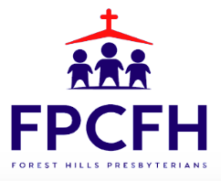
The Mission of The First Presbyterian Church of Forest Hills is to welcome all people into our diverse family of Christian faith and fellowship, to experience and celebrate God’s presence in worship and daily living, to share the love of Christ by reaching out to those in need, and to proclaim by word and deed the message of God’s love and the Gospel of Jesus Christ our Lord and Savior.

