May 2, 2021 5th Sunday of Easter 11 AM
First Presbyterian Church of Forest Hills
70-35 112th St., Forest Hills, NY 11375
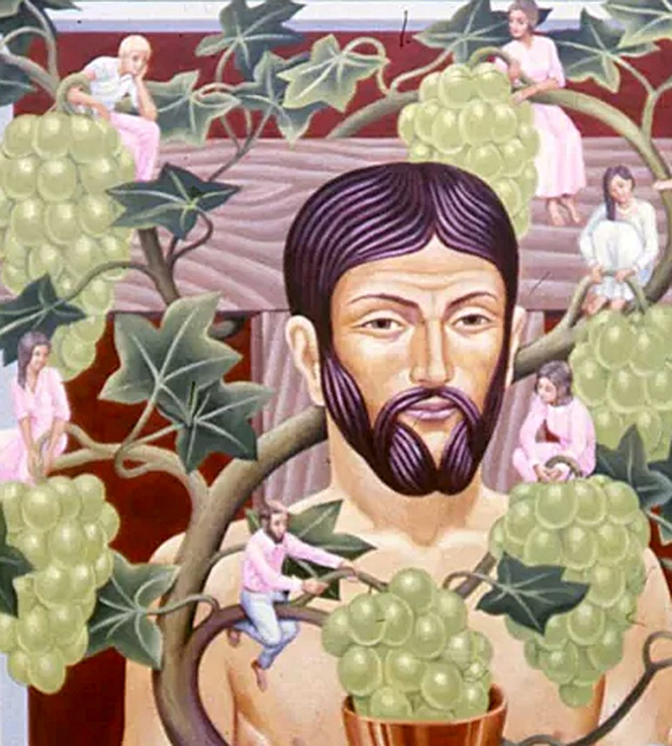
Christ the Vine, painting, 20th century; Peter Koenig
from Art in the Christian Tradition, a project of the Vanderbilt Divinity Library, Nashville, TN.

PRELUDE Prelude in D Minor - Bach David Yurick

WELCOME Jeff Courter

MINUTE FOR MISSION: PARITY

CALL TO WORSHIP

HYMN “Will You Come and Follow Me”
https://www.youtube.com/watch?v=GiXnbOORTAU

CALL TO CONFESSION

PRAYER OF CONFESSION
(A moment for silent confession.)

ASSURANCE OF GOD'S LOVE Jeff Courter

RESPONSE

PEACE Let there be peace on earth, And let it begin with me.
May God’s peace be with you.And also with you.

RESPONSIVE READING Psalm 22:25-31 (NIV) Lois DeLong
From you comes the theme of my praise in the great assembly;
before those who fear you I will fulfill my vows.
The poor will eat and be satisfied; those who seek the Lord will praise him— may your hearts live forever!
All the ends of the earth will remember and turn to the Lord, and all the families of the nations will bow down before him, for dominion belongs to the Lord and he rules over the nations.
All the rich of the earth will feast and worship; all who go down to the dust will kneel before him— those who cannot keep themselves alive.
Posterity will serve him; future generations will be told about the Lord.
They will proclaim his righteousness, declaring to a people yet unborn: He has done it!

FIRST READING 1 John 4:7-21 (NIV) Lois DeLong
⁷ Dear friends, let us love one another, for love comes from God. Everyone who loves has been born of God and knows God. ⁸ Whoever does not love does not know God, because God is love. ⁹ This is how God showed his love among us: He sent his one and only Son into the world that we might live through him. ¹⁰ This is love: not that we loved God, but that he loved us and sent his Son as an atoning sacrifice for our sins. ¹¹ Dear friends, since God so loved us, we also ought to love one another. ¹² No one has ever seen God; but if we love one another, God lives in us and his love is made complete in us. ¹³ This is how we know that we live in him and he in us: He has given us of his Spirit. ¹⁴ And we have seen and testify that the Father has sent his Son to be the Savior of the world. ¹⁵ If anyone acknowledges that Jesus is the Son of God, God lives in them and they in God. ¹⁶ And so we know and rely on the love God has for us. God is love. Whoever lives in love lives in God, and God in them. ¹⁷ This is how love is made complete among us so that we will have confidence on the day of judgment: In this world we are like Jesus. ¹⁸ There is no fear in love. But perfect love drives out fear, because fear has to do with punishment. The one who fears is not made perfect in love. ¹⁹ We love because he first loved us. ²⁰ Whoever claims to love God yet hates a brother or sister is a liar. For whoever does not love their brother and sister, whom they have seen, cannot love God, whom they have not seen. ²¹ And he has given us this command: Anyone who loves God must also love their brother and sister.

GOSPEL READING John 15:1-8 (NIV) Jeff Courter
15 “I am the true vine, and my Father is the gardener. ² He cuts off every branch in me that bears no fruit, while every branch that does bear fruit he prunes so that it will be even more fruitful. ³ You are already clean because of the word I have spoken to you. ⁴ Remain in me, as I also remain in you. No branch can bear fruit by itself; it must remain in the vine. Neither can you bear fruit unless you remain in me.
⁵ “I am the vine; you are the branches. If you remain in me and I in you, you will bear much fruit; apart from me you can do nothing. ⁶ If you do not remain in me, you are like a branch that is thrown away and withers; such branches are picked up, thrown into the fire and burned. ⁷ If you remain in me and my words remain in you, ask whatever you wish, and it will be done for you. ⁸ This is to my Father’s glory, that you bear much fruit, showing yourselves to be my disciples.

SERMON “The Fruit of Love” Jeff Courter

HYMN “They'll Know We Are Christians by Our Love”
https://www.youtube.com/watch?v=I_m4ZhFEGf4

PROFESSION OF FAITH THE NICENE CREED Lois DeLong
We believe in one God, the Father, the Almighty, maker of heaven and earth, of all that is, seen and unseen. We believe in one Lord, Jesus Christ, the only Son of God, eternally begotten of the Father, God from God, Light from Light, true God from true God, begotten, not made, of one Being with the Father; through him all things were made. For us and for our salvation he came down from heaven, was incarnate of the Holy Spirit and the Virgin Mary and became truly human. For our sake he was crucified under Pontius Pilate; he suffered death and was buried. On the third day he rose again in accordance with the Scriptures; he ascended into heaven and is seated at the right hand of the Father. He will come again in glory to judge the living and the dead, and his kingdom will have no end. We believe in the Holy Spirit, the Lord, the giver of life, who proceeds from the Father and the Son, who with the Father and the Son is worshiped and glorified, who has spoken through the prophets. We believe in one holy catholic and apostolic Church. We acknowledge one baptism for the forgiveness of sins. We look for the resurrection of the dead, and the life of the world to come. Amen.

PRAYERS OF THE PEOPLE

OFFERING / OFFERING SONG “Praise God, All You Nations” (DaNase)
Praise God, all you nations. People of God, sing praise!
Praise God, all you nations. People of God, sing praise:
God’s love is great and endures forever.
Praise God, all you nations. People of God, sing praise!

PRAYER OF DEDICATION

COMMUNION HYMN “Song of the Body of Christ”
https://www.youtube.com/watch?v=J1x6qdrix0k

SACRAMENT OF THE LORD’S SUPPER

CLOSING HYMN “Lord, Dismiss Us with Your Blessing” https://www.youtube.com/watch?v=CPWTuJ6uKTg

BENEDICTION

POSTLUDE Trumpet Tune – Purcell David Yurick
___________________________________________________________________

UPCOMING CALENDAR

MIDWEEK MEETINGS: Please join us for the following -
TUESDAY, 7:00 PM Discussion group. Please join us on Zoom:
Log in to https://zoom.us/ , then click on “join a meeting.”
This is the Meeting ID#: 820-458-1305
Or you can join us by telephone only: 646-558-8656
Wednesday Bible study – 12:00 Noon on Zoom as noted above.

First Presbyterian Church of Forest Hills
70-35 112th St., Forest Hills, NY 11375 presbyfh.org
David Barnett, Admin 718-268-4036 FirstPresFHNY@gmail.com
Nadina Grants, Clerk of Session Charlie Potter, Chair, Deacons
Samira Clarke, Nursery School Director

For offerings/donations:
- Use Zelle to make Online payments from your bank account. Use this phone number to transfer to the church: 646-577-7967
- Make checks payable to First Presbyterian Church of Forest Hills and mail check to the church office
- Go to our church website: presbyfh.org and click on the “Give Now” icon to set up a payment
- Set up a Bill pay from your bank

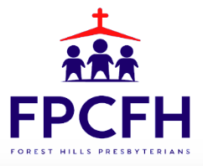
The Mission of The First Presbyterian Church of Forest Hills is to welcome all people into our diverse family of Christian faith and fellowship, to experience and celebrate God’s presence in worship and daily living, to share the love of Christ by reaching out to those in need, and to proclaim by word and deed the message of God’s love and the Gospel of Jesus Christ our Lord and Savior.

